

East West University

Design of a Full-Fledged Network with Subnets

Project Report

Computer Networks

CSE405

Submitted by:

Name: Tanjela Rahman Rosni

ID: 2020-1-60-018

Section: 02

Submitted to:

Dr. Anisur Rahman

Associate Professor

Department of Computer Science and Engineering

East West University
Objective:

Design a full-fledged network for an organization with multiple subnets.

On top of that, a webpage for University of Scholars, was to be made and it would be located through the address http://www.scholars.edu.bd/ Each Campus was also given a wireless access point to access the network. All the 6 campuses of the university were in the complex network along with sub-nets inside each campus.

Implementation Details

The network design was implemented in Cisco Packet Tracer. To incorporate all the 6 different campuses as well as connecting it to a separate Server Room, a dynamic network of routers was used. Every network was designed in such a way that all are using subnet for future extend.

Physical Diagram :
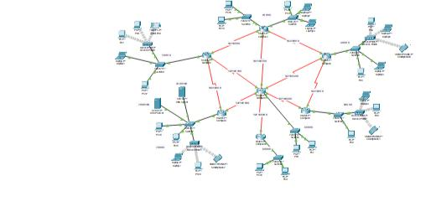
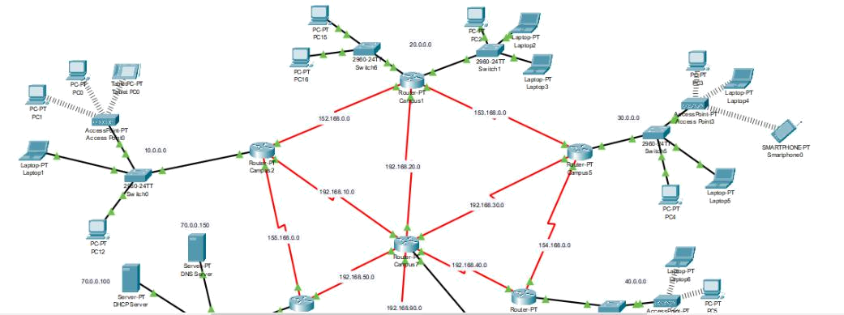
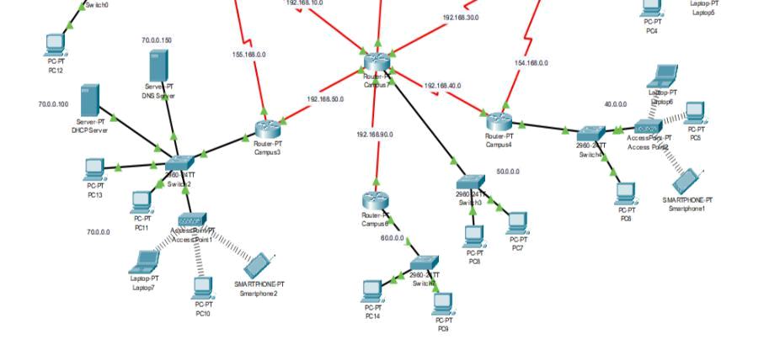

The Network elements used in the project were:

- Connectors (Straight Through Cable and Serial DCE).

- Routers.

- Switches.

- Servers.

- PCs.

- Wireless Access points.

- There were 3 servers that were used. Those were DHCP, DNS and Web Server. All these servers were kept in a Server Room, separate from all the other Campus networks. The DHCP server was used to dynamically provide IP addresses to all the hosts present in the 7 campuses including the different Sub-Nets in each campus.

- Laptops.

The Web Server was used to provide the webpage of University of professionals which can be accessed through any of the hosts in any network.
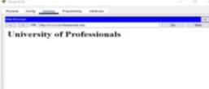

The DNS server was used so that all the hosts can access the webpage in the Web Server through the required web address instead of the IP address of the Web Server.

The wireless connections were possible through wireless Access Points present in each network. The Access Points were secured through WEP protection and the connecting devices would require password to connect to the wireless network.
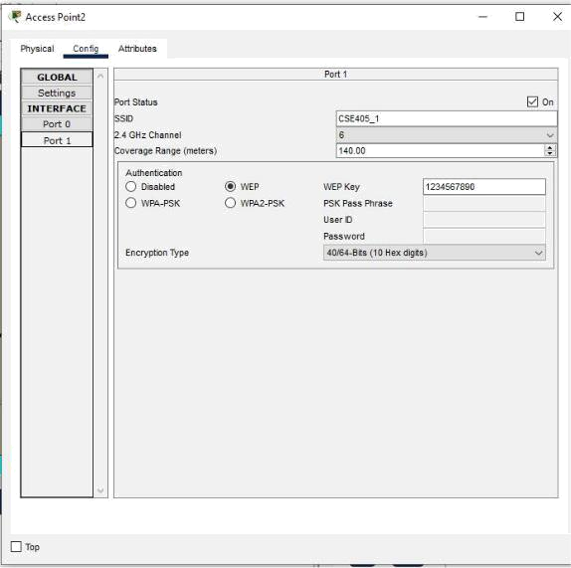

Thus, the entire network was properly connected and communications between any devices in the complex network was established.

Special Requirements:

As per the special requirements for creating this network,

- The servers were kept in a separate LAN in the form of a server room.

- DHCP server was used to dynamically provide IP address to hosts belonging to all the different networks.

- Sub-Nets were incorporated in each of the Campus Networks.

Limitations:

For consistency of this complex network we used many devices which is very costly.

Moreover, the unique server room need extra cost and maintenance.

Conclusion:

Overall, it can be concluded that complex network of University of professional’s given design was performed properly. The network design incorporated in a way that all campus can conduct together their daily activities. There was many problem establishing the network. In this project DHCP,DNS and WEB server is used as one server.

